**Abstract:**

The aim of this project is implementation of neural networks with back propagation algorithm for stock market. Borrowing from biology, researchers are exploring neural networks, no algorithmic approach to information processing. A neural network is a powerful data-modelling tool that is able to capture and represent complex input/output relationships. The motivation for the development of neural network technology stemmed from the desire to develop an artificial system that could perform “intelligent" tasks similar to those performed by the human brain. Artificial Neural Networks are being counted as the wave of the future in computing. They are indeed self-learning mechanisms which don’t require the traditional skills of a programmer. Back propagation is one of the approaches to implement concept of neural networks.

**Introduction:**

The stock market is affected by a large number of highly interrelated economical, political and psychological factors which interact with each other in a complex fashion. Since most of these relationships seem to be probabilistic and therefore cannot be expressed as deterministic rules, financial analysis is one of the most well suited and promising applications of artificial neural networks. The proposals have been made to use neural network models for prediction and forecasting problems in the financial area, such as locating sources of forecast uncertainty in a recurrent gas market model, corporate bond rating , mortgage delinquency prediction, chaotic time series prediction , prediction of IBM daily stock prices , prediction of three selected German stock prices and prediction of the weekly Standard Poor 500 index . In some of these proposals, the neural networks performed better than regression techniques or as good as the Box-Jenkins technique, while in others the results were disappointing.

In this project, we apply several alternatives of the backpropagation neural network. The basic idea is to let the network learn an approximation of the mapping between the input and output data in order to discover the accurate output. The trained network is then used to predict the weekly closing prices for the future.

Our work differs from previous stock price predictions with neural techniques [5] in the data presented to the networks. While in other approaches the input data was exclusively based on stock prices, we also consider other important economical factors, namely a subset of those considered in the fundamental and technical analysis methods used by human analysts to make their investment decisions. Thus, although we regard a neural network for stock price prediction primarily as a technical analysis tool, elements of the fundamental and the technical analysis are combined in our approach. Similar to a human analyst who is probably more successful if he or she is aware of both methods, we expect the networks to produce high quality predictions in the combined approach. Several simulation results will be presented in order to see if our expectations will be fulfilled.

Another strong trend in deep learning for text is the use of a word embedding layer as the main representation of the text. While this approach has notable advantages, word-level language models do not capture sub-word information, may inaccurately estimate embedding for rare words, and can poorly represent domains with long-tailed frequency distributions. These were motivations for character level language models showed are capable of learning high level representations despite their simplicity. These motivations seem applicable in our domain: character-level representations can for example generalise across numerical data like percentages (e.g. the terms 5% and 9%) and currency, and can handle the large number of infrequently mentioned named entities. Character level models are also typically much more compact. In this work we propose an automated trading system that, given the release of news information about a company, predicts changes in stock prices. The system is trained to predict both changes in the stock price of the company mentioned in the news article and in the corresponding stock exchange index (S&P 500). We also test this system for both intraday changes, considering a window of one hour after the release of the news, and for changes between the closing price of the current trading session and the closing price of the next day session. This comparative analysis allow us to infer whether the incorporation of new information is instantaneous or if it occurs gradually over time. Our model consists of a recurrent neural network pre-trained by a character level language model. The remainder of the paper is structured as follows: We describe event-driven trading and review the relevant literature. We describe our model and the experimental setup used in this work. We presents and discuss the results. Finally, we summarize our work and suggest directions for future research.

**Architecture Diagram:**

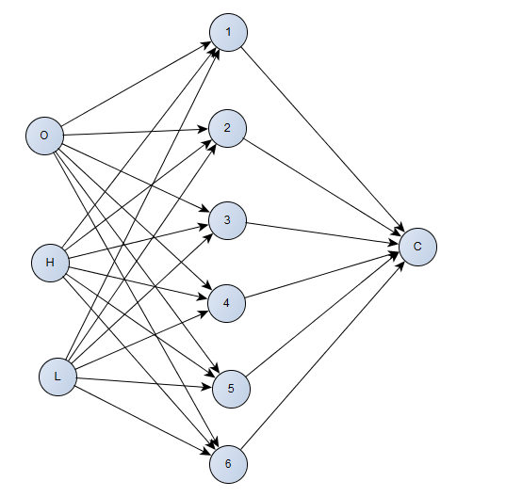

**Literature Survey:**

Normalization: A Preprocessing Stage

S. Gopal Krishna Patro1, Kishore Kumar sahu2

Research Scholar, Department of CSE & IT, VSSUT, Burla, Odisha, India1

Assistant Professor, Department of CSE & IT, VSSUT, Burla, Odisha, India2

This paper discuss the normalization is a pre-processing stage of any type problem statement. Especially normalization takes important role in the field of data mining, soft computing, cloud computing etc. for manipulation of data like scale down or scale up the range of data before it becomes used for further stage. There are so many normalization techniques are there namely Min-Max normalization, Z-score normalization and Decimal scaling normalization. So by referring the normalization techniques we are going to propose one new normalization technique namely, **Integer Scaling Normalization**. In addition, we are going to show our proposed normalization technique using various data sets.

The MIN MAX normalization formula is:

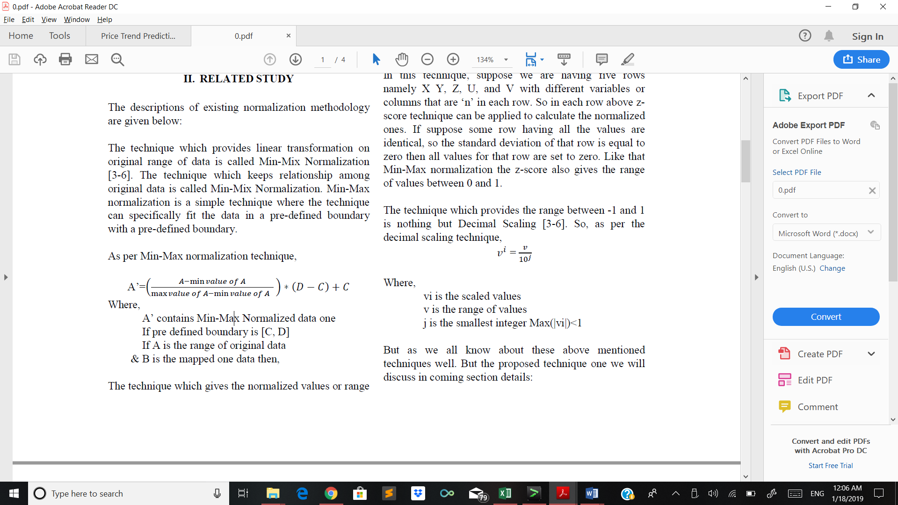

This works for the data that are not even and have the difference that is more than usual. In our stock market we need values from to or the neural network to learn.

The Z-score normalization:



But, these methods are often used. In this paper a new normalization method known as Integer Scaling Normalization (ISN) removes the value of 0 and 1 instead provide the appropriate values:

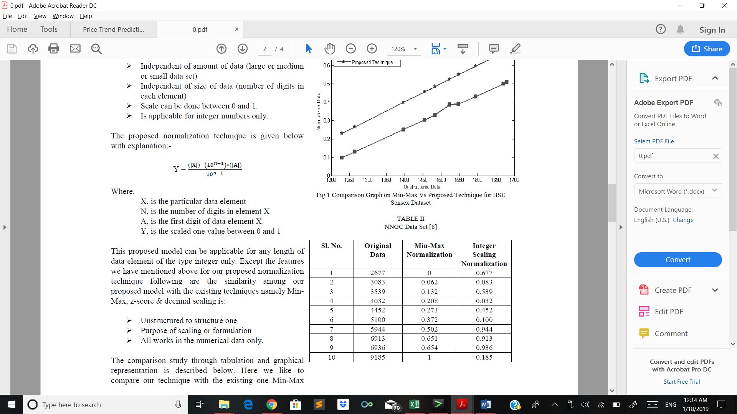



The Drawback of this paper is that it only works for integer values. In case of decimal values that we have in our project, this integer scaling normalization is not suitable for it. Therefore, we use MIN MAX normalization technique for the dataset that we have.

Price Trend Prediction of Stock Market Using

Outlier Data Mining Algorithm

2015 IEEE Fifth International Conference on Big Data and Cloud Computing

Zhao, Lei - Baylor University

Wang, Lin - Japan Advanced Institute of Science and Technology

In this paper it was discussed a novel data miming approach to predict long term behavior of stock trend. Traditional techniques on stock trend prediction have shown their limitations when using **time series algorithms or volatility modelling** on price sequence. A novel outlier mining algorithm is proposed to detect anomalies on the basis of volume sequence of high frequency tick-by tick data of stock market. Such anomaly trades always inference with the stock price in the stock market. By using the cluster information of such anomalies, our approach predict the stock trend effectively in the really world market. Experiment results of this paper show that the proposed approach makes profits on the Chinese stock market, especially in a long-term usage.

These were the steps in this paper:

1. The anomalies on distribution of trading volume to predict upward trend of stock prices.
2. They use tick-by-tick data instead of time series data on stock price in a novel outlier-mining algorithm.
3. They select 200 stocks randomly in our experiment. The result shows that using anomalies can predict the upward trend of stock prices effectively.

Tick-by-Tick:

Tick-by-tick data is a kind of format used frequently in financial industry. This data records each trade for every stock in the market, if there’s 1000 trades for a specific stock then there will be 1000 records for that stock on that day, so for a relatively long period the data size can be very big. One record of the tick-by-tick data is defined as:

R = {t, p, c, v, a, b}



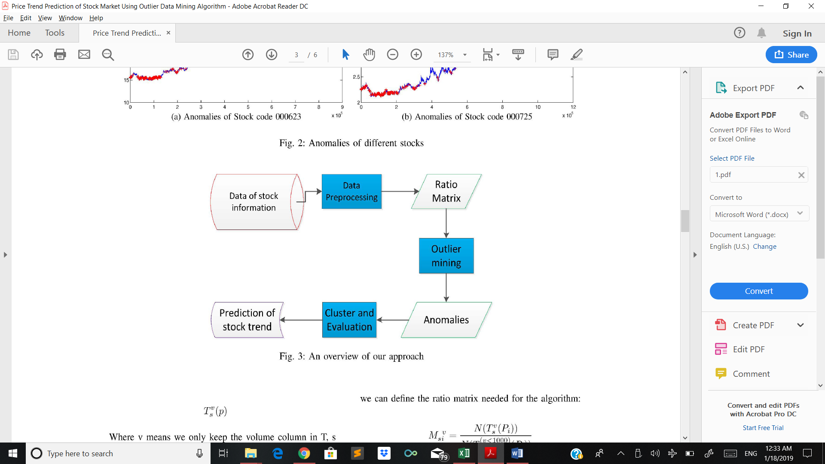

The drawback of this paper is the difference between them and if that difference is bigger than a certain limit then an anomaly is found. However, tested the novel outlier-mining algorithm and found that it is consistent with k-means clustering algorithm.

The conclusion of this paper is that the average return and successful rate is tested against our algorithm and the prediction about these two quantities is correct and satisfactory.

Survey of Stock Market Prediction Using

Machine Learning Approach

International Conference on Electronics, Communication and Aerospace Technology ICECA 2017

ASHISH SHARMA HOD Govt. Women’s Polytechnic, Indore

**DINESH BHURIYA** Govt. Women’s Polytechnic, Indore

**UPENDRA SINGH**

This paper discuss the stock market is basically nonlinear in nature and the research on stock market is one of the most important issues in recent years. People invest in stock market based on some prediction. For predict, the stock market prices people search such methods and tools which will increase their profits, while minimize their risks. Prediction plays a very important role in stock market business which is very complicated and challenging process. Employing traditional methods like fundamental and technical analysis may not ensure the reliability of the prediction. To make **predictions regression analysis** is used mostly. In this paper, they survey of well-known efficient regression approach to predict the stock market price from stock market data based. In future, the results of multiple regression approach could be improved using more number of variables.

The regression methods are:

* Polynomial regression
* RBF regression (radial base function)
* Sigmoid regression
* Linear regression

According to the paper, the RBF regression is most beneficiary for the prediction since the linear regression does not count the all data. Based on the type of prediction we use different regression methods.

The main drawback of this paper is that they did not conclude which is the best in all the regression methods. Instead, they roughly gave the details of the methods in regression and how they are used.

Prediction of Stock Market Indices – Using SAS

B.Siddhartha Reddy

Research Facilitation Center

IBS Bangalore

Bangalore, Karnataka (state), INDIA

This paper details the **SAS system** (Statistical Analysis System) has a powerful suite of tools for analyzing and forecasting data taken over a selected time period. The paper concentrates more on stock market (NSENifty, India) & its prediction; this is by the way a large and risky venture. knowledgeable investors base their predictions based either on fundamental Analysis, or technical Analysis, or both. However, most of the investors rely on the tips given by the experts for stock market predictions. However, there are many such models available such as Interrupted Time Series, Auto Regression (AR), Exponential Smoothening, Moving Average (MA), and Distributed Lags Analysis. The procedures forecast, **ARIMA** process will be illustrated in this paper.

The NIFTY MIDCAP 50, one can determine various trends the market has seen on day-today basis-the process which includes determining the trends underneath the data series. The methodology used in this paper is:

* Collection of secondary data from market source such as national stock exchange of Nifty.
* Minimizing the data series for accurate prediction.
* Making the data as stationary series so that the data would be a crisp and fetch a good forecasting
* Using various models like auto regression (AR), Moving average (MA)
* Forecasting and making a graph and matching them to the real time stock market.

The drawback of this paper is that the **long-term prediction** is not possible since the data from time series are heavily depend on available data and the data from real time is not possible to access. The prediction of long term is difficult as the value of data depends on other factors also. AR model do have some limitations, which would result in an inaccurate prediction since these predicted values may sometimes have a huge difference with that of the real time values caused due to the external factors.

Optimised Prediction Model For Stock Market Trend Analysis

Proceedings of 2018 Eleventh International Conference on Contemporary Computing (IC3), 2-4 August, 2018, Noida, India

Dr. Devpriya Soni1, Sparsh Agarwal, Tushar Agarwal,

Pooshan Arora, Kopal Gupta

Department of CSE, Jaypee Institute of Information Technology, Noida, Uttar Pradesh, India

The main objective of this work in this paper is to add to the academic understanding of stock market analysis using some well-defined algorithms and machine learning techniques. Many a method like technical analysis, fundamental analysis, time series analysis and statistical analysis, etc. have been used in an attempt to analyze the share trends in the market but none of these methods have so far proved to be a universal approach o acceptance as a prediction tool.

The intricacy while analyzing market trends is that they have a dependency on a number of external factors some of which are not under one’s control. Using some machine learning and nature inspired techniques, such Decision Tree, PSO, Black Hole, Naïve Bayes. After analyzing the trends with the help of standard techniques, they proposed an entirely new approach to analyze stock market indices over which accuracy is calculated and compared over different techniques and algorithms. They finally tested our model on the one year of Nifty stock index dataset at real time where we analyzed the values based on data from the past days for three months.

In the proposed model, divide the dataset into two parts i.e. the **training set and the testing set**. The training set are used to train the data and learn about the share qualities while the testing set is used for prediction. Then form a matrix of 0 and 1. If the stock falls its is marked as 0 and if it raises it is made as 1. Count the zero and one. If number of 1’s are more than 0’s, make it as a good share or otherwise it is a bad share. Take a value y and from the first day onwards if it’s a good share increment y value, if it’s a bad shar then decrement the y value. Prepare a matrix of the y. Form a matrix x, with real rise of the or drop of the share and compare it with the y matrix. Using an crisp algorithm in y value to train the matrix so that the values may come accurate.

The mean accurate of the proposed model is more accurate when compared to other model. The drawback of this model is there is more preprocessing step is required to make the input to matrix model.

Short-term Prediction for Opening Price of Stock Market Based on Self-adapting Variant PSO-Elman Neural Network

Ze Zhang, Yongjun Shen, Guidong Zhang, Yongqiang Song, Yan Zhu

School of Information Science& Engineering Lanzhou University Lanzhou,

Gansu Province, China

E-mail: [shenyj@lzu.edu.cn](mailto:shenyj@lzu.edu.cn)

**Analysis :**

Typically, Elman neural network is a local recurrent neural network, having one context layer that memorizes the past states, which is quite fit for resolving time series issues. Given this, this paper takes Elman network to predict the opening price of stock market. Considering that Elman network is limited, this paper adopts self-adapting variant PSO algorithm to optimize the weights and thresholds of network. Afterwards, the optimized data, regarded as initial weight and threshold value, is given to Elman network for training, accordingly the prediction model for opening price of stock market based on self-adapting variant PSO-Elman network is formed. Finally, this paper verifies that model by some stock prices, and compares with BP network and Elman network, so as to draw the result that shows the precision and stability of this predication model both are superior to the traditional neural network.

Advantages :

1. The complexity of this data set is low.
2. The experiments have proved that self-adapting variant PSO-Elman neural network has good fault tolerance.
3. If this model is used to predict when there are no significant fluctuations in stock market, the result is quite accurate.

Stock Market Prediction Using Hidden Markov Model

Poonam Somani

Department of Computer Engineering and Information Technology

College of Engineering Pune Maharashtra, India

Email: [somanipoonam7393@gmail.com](mailto:somanipoonam7393@gmail.com)

Shreyas Talele

Department of Computer Engineering and Information Technology

College of Engineering Pune Maharashtra, India

Email: [shreyastalele@gmail.com](mailto:shreyastalele@gmail.com)

Suraj Sawant

Department of Computer Engineering and Information Technology

College of Engineering Pune Maharashtra, India

Email: [sts.comp@coep.ac.in](mailto:sts.comp@coep.ac.in)

**Analysis :**

This paper aims at surveying recent literature in the area of Neural Network, Hidden Markov Model and Support Vector Machine used to predict the stock market ﬂuctuation. Neural networks and SVM are identiﬁed to be the leading machine learning techniques in stock market prediction area. Also, a model for predicting stock market using HMM is presented. Traditional techniques lack in covering stock price ﬂuctuations and so new approaches have been developed for analysis of stock price variations. Markov Model is one such recent approach promising better results. In this paper a predicting method using Hidden Markov Model is proposed to provide better accuracy and a comparison of the existing techniques is also done.

Advantages :

1. Markov Model is more efﬁcient in extracting information from the dataset.
2. it has a strong foundation so it is easier to explain the reason of the outcome.

Stock Market Prediction Based on Interrelated Time Series Data

2012 IEEE Symposium on Computers & Informatics978

Ryota Kato and Tomoharu Nagao

Graduate School of Environment and Information Sciences,

Yokohama National University Kanagawa, Japan

Email: [ryota@nlab.sogo1.ynu.ac.jp](mailto:ryota@nlab.sogo1.ynu.ac.jp)

**Analysis :**

They propose a stock market prediction method based on interrelated time series data. Though there are a lot of stock market prediction models, there are few models which predict a stock by considering other time series data. Moreover it is difﬁcult to discover which data is interrelated with a predicted stock. Therefore they focus on extracting interrelationships between the predicted stock and various time series data, such as other stocks, world stock market indices, foreign exchanges and oil prices. they test their method for predicting the daily up and down changes in the closing value by using discovered interrelationships, and experimental results show that our methods can predict stock directions well, especially in the manufacturing industry.

This pattern used in time series data is Evolution Strategy.

In this paper we proposed the methods that extract interrelationships of changes in prices between the predicted stock and various time series data, such as other stocks, world stock market indices, foreign exchanges and oil prices.

qq.PNG

The drawback in this evalution stratogey is used in only inter related time series data but not varient data.

Stock Market Prediction Using an Improved Training Algorithm of Neural Network

2nd International Conference on Electrical, Computer & Telecommunication Engineering (ICECTE) 8-10 December 2016, Rajshahi-6204, Bangladesh

Mustain Billah

Department of Information And

Communication Technology

Mawlana Bhashani Science And

Technology University Tangail,

Bangladesh.

Sajjad Waheed

Department of Information And

Communication Technology

Mawlana Bhashani Science And

Technology University Tangail,

Bangladesh.

Abu Hanifa

Department of Information And

Communication Technology

Mawlana Bhashani Science And

Technology University Tangail,

Bangladesh.

**Analysis :**

In this paper, an improved Levenberg Marquardt(LM) training algorithm of artiﬁcial neural network has been proposed. Improved Levenberg Marquardt algorithm of neural network can predict the possible day-end closing stock price with less memory and time needed, provided previous historical stock market data of Dhaka Stock Exchange such as opening price, highest price, lowest price, total share traded. Morever,improvedLMalgorithmcanpredictday-endstockprice with 53% less error than ANFIS and traditional LM algorithm. It also requires 30% less time, 54% less memory than traditional LM and 47% less time, 59% less memory than ANFIS.

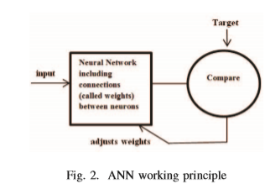

Step 1: Set Q = 0, g = 0 andPerformance Index,

F(w)=

p p=1 m m=1

e2pm2;

Step 2: According to performance Index F(w), compute jpm;

Step 3: Compute qpm;

Step 4: Compute ηpm;

Step 5: Compute Δ w according to Δw =(Q + μI)−1g;

Step 6: Evaluate the error at the new weigh vector;

Step 7: If error <previous error

w = w +Δw μ = μ×1.5 gotostep2;

else

μ =

μ 5 gotostep4;

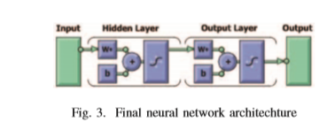

In this paper, an improved Levenberg Marquardt(LM) algorithm of Artiﬁcial Neural Network(ANN) has been proposed. Then, this improved algorithm has been applied for stock market closing price prediction. Generally Adaptive Neuro Fuzzy Inference System(ANFIS) based model performs better

prediction than ANN. But if ANN uses this improved algorithmfortraining,itshows53%moreaccuracyinstockprediction than ANFIS.

Developing a Prediction Model for Stock Analysis

2017 International Conference on Technical Advancements in Computers and Communications

R. Yamini Nivetha

Department of Computer Science and Engineering.

Adhiparasakthi Engineering College Melmaruvathur, Kanchipuram District [nive.yamini91@gmail.com](mailto:nive.yamini91@gmail.com)

Dr. C. Dhaya

Department of Computer Science and Engineering.

Adhiparasakthi Engineering College Melmaruvathur, Kanchipuram District dhaya.c@gmail.com

**Analysis :**

In this work, various prediction algorithms are analyzed to build a prediction model. The prediction model will be based on monthly prediction and daily prediction to forecast the next day market price. This model estimates the open value of the next day in the market. Sentiment Analysis needs to identify and extract sentiments from each individual in the social media. The correlation between the sentiments and the stock value is to be determined. A comparative study of these three algorithms: Multiple Linear Regression, Support Vector Machine and Artificial Neural Network are done. The stock price is predicted by sentiment analysis with the best forecasting algorithm.

**PROBLEM DEFINITION :** The stock market prediction is difficult since the stock price is dynamic in nature. To reduce the false forecasts of the stock market and increase the ability to predict the market movements. To avoid the risk and the complex in predicting stock price.

System design :

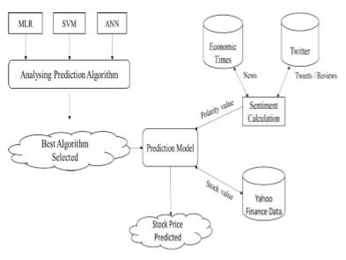

The purpose of this study is to compare the performance of the three prediction algorithms Multiple Linear Regression, Support Vector Machine, Artificial Neural Network in the stock market.

The Support Vector Machine algorithm is a two-class classifier for the learning model. The Artificial Neural Network is the classification algorithm for deep learning. The result exhibits that the deep learning algorithm performs better than the MLR and SVM.

A Data mining algorithm to analyse stock market data using lagged correlation.

Cicil Fonseka

School of Computing and Mathematics

University of Western Sydney Campbelltown, Australia

[cfons@doh.health.nsw.gov.au](mailto:cfons@doh.health.nsw.gov.au)

Liwan Liyanage

School of Computing and Mathematics

University of Western Sydney Campbelltown, Australia

l.liyanage@UWS.edu.au

**Analysis :**

The primary motivation of this paper is threefold. First, this research examines and analyses the use of market-wide lagged correlation analysis as a forecasting tool. Specifically the ability of one stock to predict the future usually short term future trends of a closely correlated another stock. Second, this paper endeavours to determine the feasibility and practicality of using lagged correlation analysis as a forecasting tool for the individual investor. Finally this paper specifies the general algorithm for the process so that it can be automated in a data mining technique

This paper developed an algorithm for predicting the market direction more accurately when two stocks are strongly correlated to each other with a lag of K number of trading days. A generic algorithm is specified so that an automated data mining process can be programmed. This will identify the stocks that are closely related, display the daily price movements and its direction side by side and forecast the direction of the price movement for the dependent stock as well as clearly showing the applicable lag which is the forecasting horizon.

Prediction of Stock Market by Principal Component Analysis

2017 13th International Conference on Computational Intelligence and Security

Muhammad Waqar, Hassan Dawood,Muhammad Bilal Shahnawaz,

Mustansar Ali Ghazanfar

Software Engineering Department

University of Engineering and Technology Taxila, Pakistan

[mwaqar588@gmail.com](mailto:mwaqar588@gmail.com),

[Hassan.dawood@uettaxila.edu.pk](mailto:Hassan.dawood@uettaxila.edu.pk),

bilalbajwa3840@gm ail.com,

[mustansar.ali@uettaxila.edu.pk](mailto:mustansar.ali@uettaxila.edu.pk)

Ping Guo

Image Processing and Pattern Recognition

Laboratory Beijing Normal University Beijing,

China pguo@bnu.edu.cn

**Analysis :**

In this paper, the problem of high dimensionality of stock exchange is investigated to predict the market trends by applying the principal component analysis (PCA) with linear regression. PCA can help to improve the predictive performance of machine learning methods while reducing the redundancy among the data. Experiments are carried out on a high dimensional spectral of 3 stock exchanges such as: New York Stock Exchange, London Stock Exchange and Karachi Stock Exchange. The accuracy of linear regression classification model is compared before and after applying PCA. The experiments show that PCA can improve the performance of machine learning in general if and only if relative correlation among input features is investigated and careful selection is done while choosing principal components. Root mean square error (RMSE) is used as an evaluation metric to evaluate the classification model.

This paper has underlined the utilization of PCA to improve the performance of machine learning model in classification of high dimensional data.

It is verified that PCA always does not guarantee for improved accuracy. Sometime through the use of PCA, some low errors can be achieved despite a major reduction of input data which may result an overall reduction in accuracy of classification model.

Application Study of BP Neural Network on Stock Market Prediction

2009 Ninth International Conference on Hybrid Intelligent Systems

Feng Li, Cheng Liu

Economic Management Institute

University of Science and Technology Beijing China, Beijing, 100083

[lifeng670312@sina.com](mailto:lifeng670312@sina.com)

**Analysis :**

This paper analyzes principles of stock prediction based on BP neural network, provides prediction model for stock market by utilizing three-layered feed forward neural networks, presents topology of network, principles of determining the number of hidden layers, selection and pretreatment of sample data and determination of preliminary parameters. In order to avoid local extremum and promote convergence speed, Levenberg-Marquardt BP algorithm has been adopted. Simulation experiment based on representative index from Shanghai stock exchange market, through training on selecting samples and prediction model, indicates that this algorithm can make efficient short-term prediction.

This paper studies principles and general steps of application of BP model to stock market prediction

In this paper, they mainly discuss steps and methods of using BP network to predict stock market, including sampling principles, principles of determining the number of node in hidden layers.

This paper presents the setting up of model, and actually predicts the closing index of Shanghai Stock Exchange Center.

BP network model is appropriate for prediction for time order.

**Normalization of data:**



We used MIN MAX normalization method for normalizing the data. Since the neural network takes the values between 0 to 1.